Fitness 2
Name | Type | Description | Picture/Barcode | Repetitions | Time
Steps | Cardio | Run up the stairs and down with high knees and a straight back | 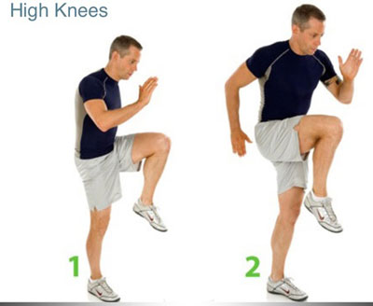 | 1-4 times every step  2-3 times every step, 2 time every other step  3-5 times every step, 2 times every other step
Mountain climbers | Cardio and arms | Set up like in a plank. Bring the right foot up to your right hand, and then back in plant position. Switch with left food. | 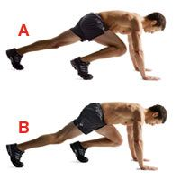 |  | 1-30 seconds  2-45 seconds  3-45 seconds with hands balancing on a ball
Tricep dips | Arms | Place your hands behind you on the step. Have your feet shoulder width apart. Dip your body down (don’t have your butt touch the ground). Elbows and arms create a 90 degree angle. | 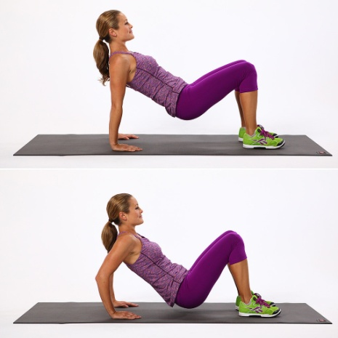 | 1-10 times  2-12 times with a step under your hands  3-18 times with a step under your hands
Side Body Squats | Legs | Side step with your right foot to a comfortable distance and squat. The right knee is above the right foot. Switch legs. |  | 1-8 each leg  2-11 each leg  3-16 each leg
Twist plank | Core and arms | Move from your waist. Whenever you twist, make sure the movement happens from your bottom rib up. Keep hips still. Come all the way up, then swing to the other side. KEEP BACK, BUTT, LEGS ALIGNED TOGETHER! |  |  | 1-20 seconds  2-35 seconds  3-50 seconds

Do all and do proper form. PICK THE LEVEL THAT FITS YOU. Let your fitness group push each other. YOU CAN ALWAYS DO MORE!

