Fitness 3
Name | Type | Description | Picture/Barcode | Repetitions | Time
Run | Cardio | Run to the yellow line and back (about 25 meters) | 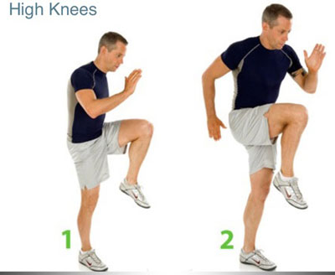 | To other side of the gym and back.  1—jog there and back  2—sprint there and jog back  3—sprint there and sprint back
Upward Facing Plank+  Dip+Lifts | Arms+Core | Arms extended straight in a plank position, but you are facing up. Lift the left leg, then right, and then dip down like a tricep dip. | 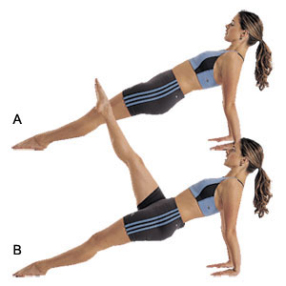 | 1—Bent knees (in a “crab” position) 8 each leg and 8 dips  2—Straight legs 7 each leg and 7 dip  3—Straight legs 10 each leg and 10 dip
Run | --------------------> | ------------------------------------> | ---------------------------------------> | To other side and back
Side Push ups | Arms | Lay down on your side with one arm folded across your body and the other bent with the hand down on the ground by your chest. Lift up. | 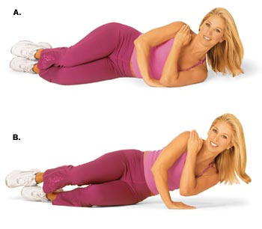 | 1—6 each side  2—9 each side  3—12 each side
Run | --------------------> | ------------------------------------> | ---------------------------------------> | To other side and back
Reverse Lunge twist | Legs | Like a regular lunge, but instead of stepping forward, you step back. Knee above ankle! |  | 1—10 each side  2—13 each side  3—16 each side
Run | --------------------> | ------------------------------------> | ---------------------------------------> | To other side and back
V-Twist | Core | Sit back on your tail bone with your legs up and your back up (creating a V). Twist to the left and right. |  |  | 1—30 seconds  2—45 seconds  3—40 seconds with twist left, then reach up to your toes, then reach right, then up, etc.

DO CORRECT FORM! Do you best and set a goal to reach. PICK THE LEVEL THAT FITS YOU. Let your fitness group push each other. YOU CAN ALWAYS DO MORE!

